Docker Task

**Step 1:- Creating EC2 instance in the AWS**

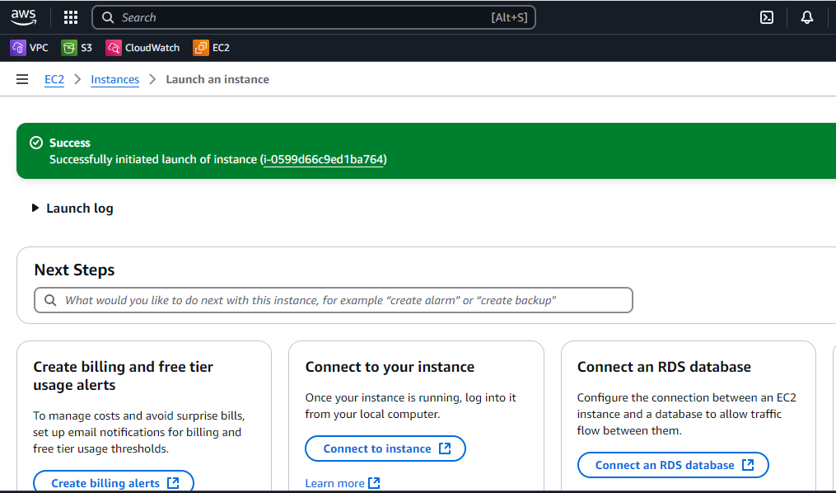

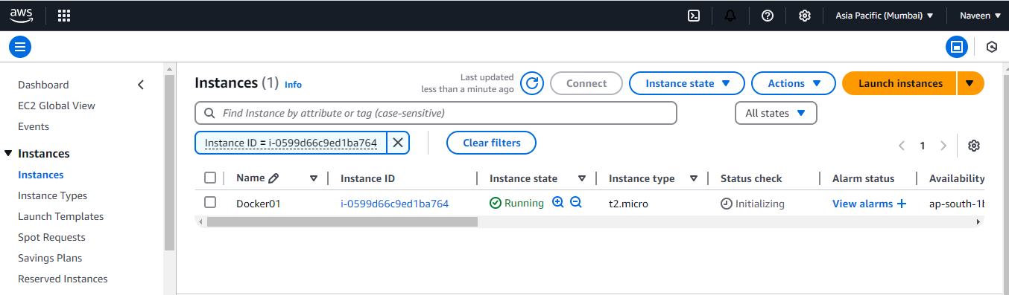

**Step 2:- Installing docker in the created EC2 machine**

* Run the below command to switch to super user

**Sudo su**

* Run the below command to update the dependencies

**Apt update**

* Run the below command to install the docker in the EC2

**apt install docker.io**

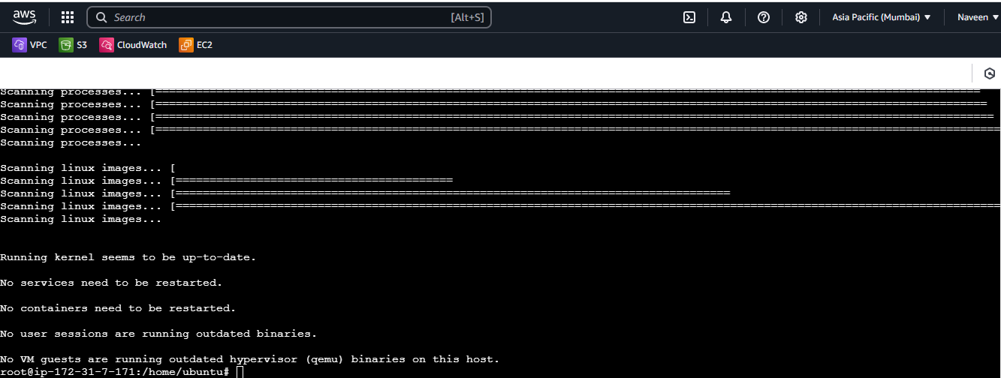

* Run the below command to check the version of the docker

**docker –version**

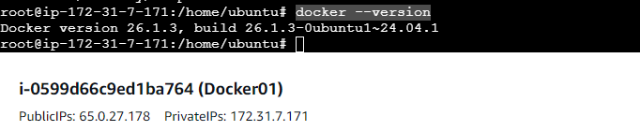

**Step 3:- pulling the Apache (httpd image from docker hub)**

* Run the below command from docker hub to pull httpd image from docker dub

**docker pull httpd**

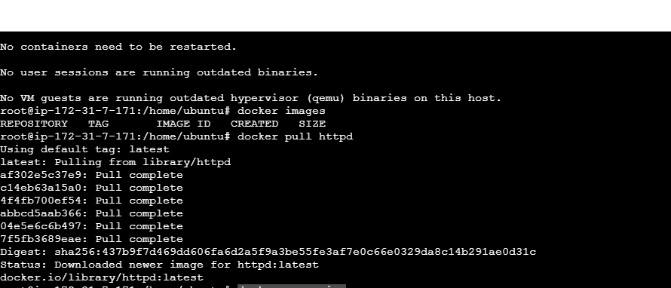

* Run the below command to list the images

**Docker images**

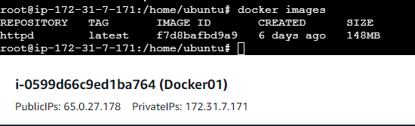

* Run the below command to create container for the httpd image pulled from docker hub

**docker run -itd -p "9090:80" httpd**

* 9090 is the port from VM and 80 is the default port for httpd

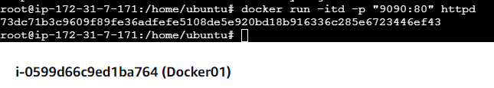

* Run the below command to list the containers created

**Docker ps**

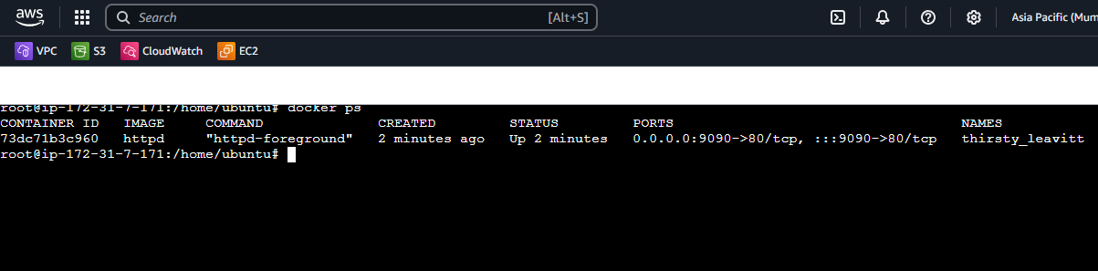

* Run the below command to create volume

**docker volume create volume1**

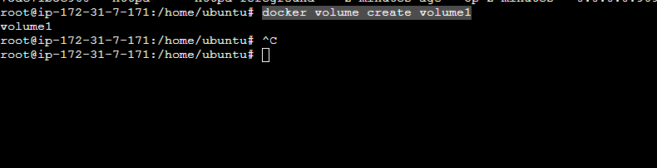

* Run the below command to list the volume created

**Docker volume ls**

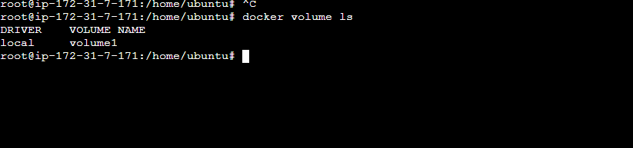

* Run the below command to list the network used by the container bridge is the default network used by the container when it is created.

**docker network ls**

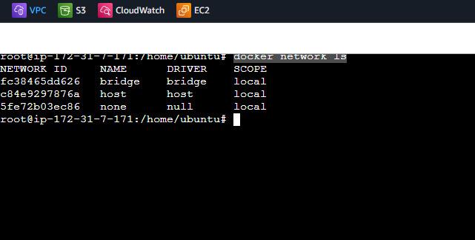

* Run the below command to display the information about the bridge network

**docker network inspect bridge**

